**Ribbon Tab -**



**Name Box –**



**Workbook Name –**



**Group Name –**

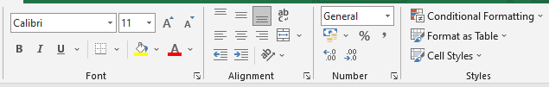

* Worksheets can be renamed either with a double click or right click>rename option
* Concat Method 2 cells =CONCAT(B3,C3)
* Concat method Multiple cells =CONCAT(B3:D3)
* We can use textjoin function and it will help us to perform concatenation with delimiter/separator =TEXTJOIN(" ",TRUE,B3:E3)
* Blank space is our delimiter/separator here and the true is an argument that denoted “empty cells will be ignored”
* Switch function is used to compare / evaluate a set of values against another set.